Experience of Sexual Violence Anomaly Detection with Isolation Forest & Z-Score Techniques
The Uganda Demographic and Health Surveys (UDHS) are generally conducted every four to five years to monitor health and population indicators in Uganda. The 2016 survey that features as the latest year in the case study was the sixth in the series, following previous surveys that started in 1988-89.
The data shows the percentage of women and men (15–49) who have ever experienced sexual violence (lifetime and past 12 months) by background characteristic.
Why This Dataset?
I chose this dataset because it seemed like it had quite a few outliers and/or anomalies after skimming through the excel sheet and saw 3 negative values in one single row that wasn’t in any other rows of the entire dataset.
The only way to uncover what was beneath was to delve into statistical methods and machine learning to know the anomalies present in the dataset.
Columns include:
‘Period’: represents the year in which the survey was done
‘background': comprises of the ethnicity, religion, age, marital status, employment status, number of children, wealth quantile, residence, regions, totals.
'particulars’: shows the details of the background column
'w_life': percentage number of women who have ever experienced sexual violence in their life time.
'w_past12': percentage number of women who have experienced sexual violence in the past 12 months.
'women_total': summation of women who have experienced sexual violence for the particular background column.
'm_life': percentage number of men who have ever experienced sexual violence in their life time.
'm_past12 ': percentage number of men who have experienced sexual violence in the past 12 months.
'men_total': summation of men who have experienced sexual violence for the particular background column.

Why I used Isolation Forest
- Isolation Forest is fast and easy to interpret & also scales well to large datasets.
- Isolation Forest works well with unsupervised data i.e., no need to label data.
- Isolation Forest doesn't rely on assumptions about the data's underlying distribution unlike methods like One-Class SVM or simple Z-score.
- Isolation Forest works well on small–medium tabular datasets such as the one in study.
- Isolation Forest naturally handles multiple features at once which is crucial for finding groups where the combination of percentage and count is anomalous.
- By including log (sample size) as a feature, it automatically down-weights extreme percentages that come from tiny samples (small-n variation is normal) and flags extreme percentages that come from large samples (more trustworthy, therefore more surprising).
- Isolation Forest is robust to the negative/suppressed values i.e. convert them to NaN.

Why I used Z-Score
I needed a comparison of how many anomalies I would get from the statistical method z-score and the Isolation Forest, then later see the anomalies that existed in both anomaly detection techniques.

Data Pre-Processing
Shortening the long unreadable column names
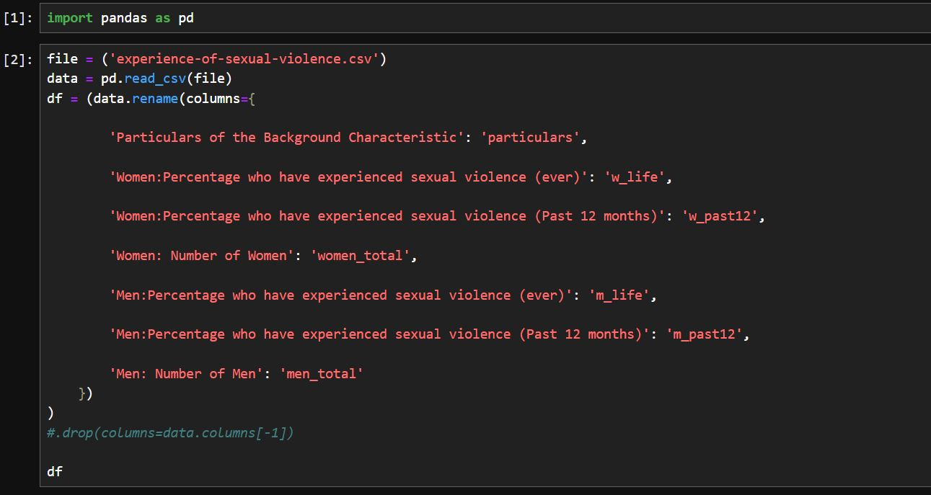
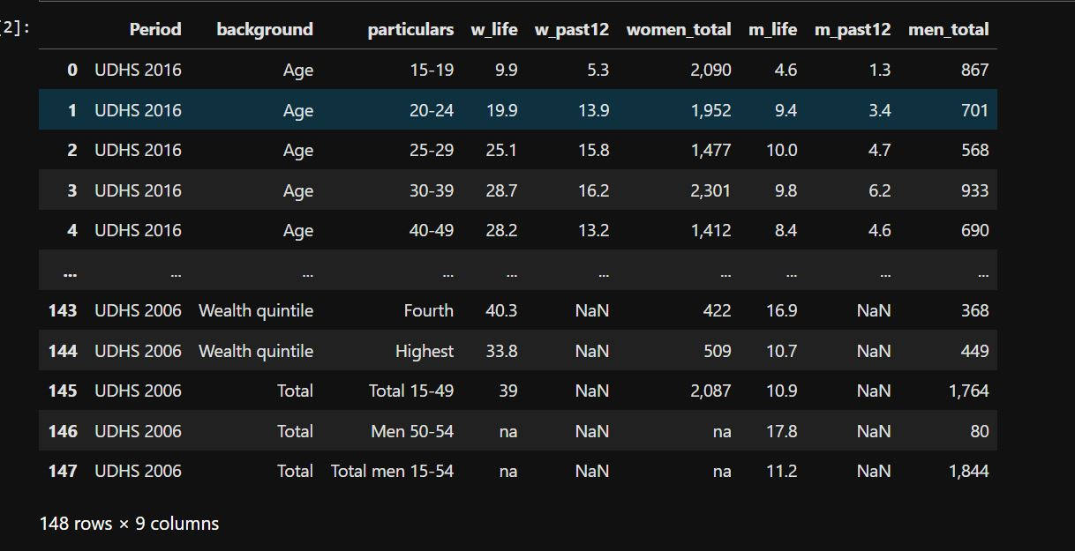
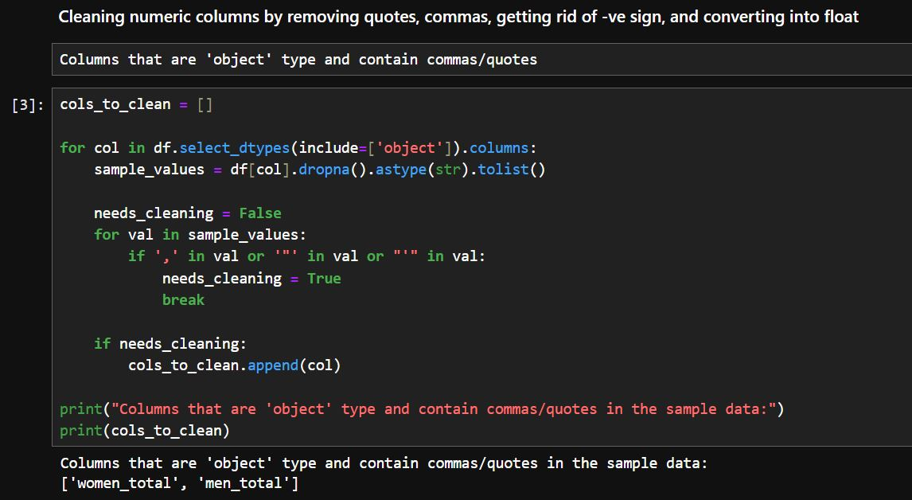
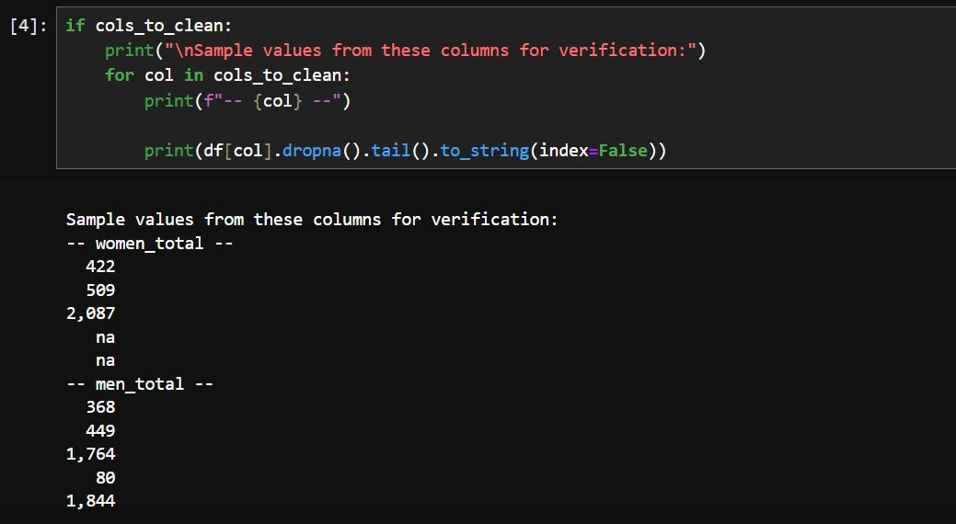
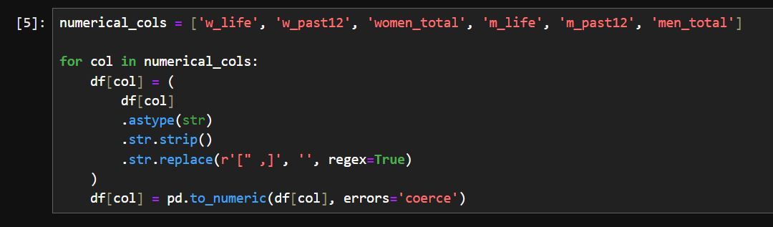
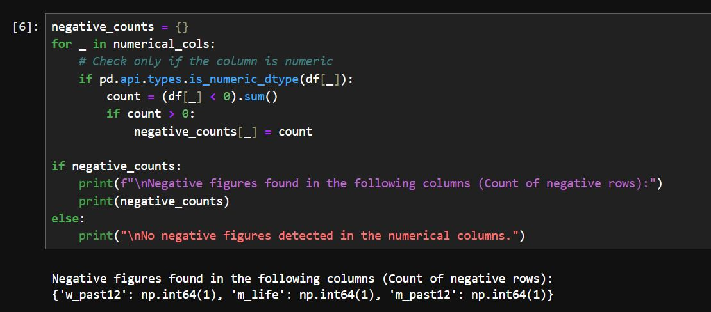

1st Anomaly detected were the negative values under the;
Period: UDHS 2011,
Background: Religion,
Particulars: SDA/Other,
w_past12: -16.7,
m_life: -10.8,
m_past12: -6.3
These are isolated values since the rest of the dataset has positive numerical values.

Next Steps
I had conflicting thoughts dealing with the negative values. Specifically, when it came to the conversion of the negative values into positive ones. Usually, one would just change the negative into a positive for many datasets assuming that it was a mistake during data entry since it was an isolated single row with the negative values.
However, for this analysis, there was some information that triggered more research using A.I and the Demographic & Health surveys website for data types and formats regarding the survey. I discovered that;
- The data for that specific variable could have not been collected or was missing, and the software (like Stata or SPSS) assigned a system-defined missing value, which often displays as a negative number.
- The question or module was not applicable to that specific respondent. For example, some questions about maternal health may not apply to male respondents, and a specific negative value would be used to denote this.
- The data provider or user may have assigned negative values as codes for specific types of non-response during data processing.
Subsequently, The DHS website didn’t have detailed documentation on the negative notations. I therefore used my intuition and the context of the data to conclude that the values should be converted to positives since they have a negligible difference to the near by numbers if the negative sign is removed. Also, there was a correlation with the neighbouring numbers from the same column if the negative sign was removed.
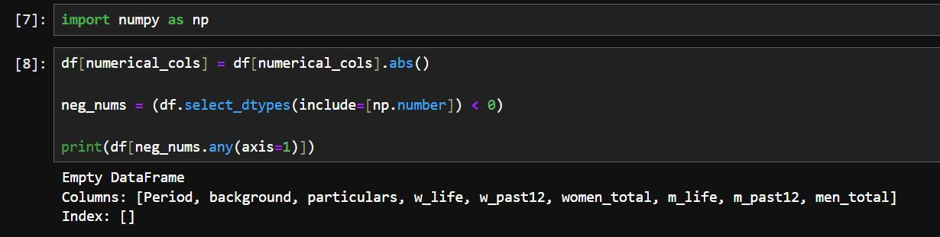
Exploratory Data Analysis
removed

